Selasa, 27 November 2018

REACTJS PART II (ROUTER, REDUX, RESTFUL API, JWT ETC)
by Mas Amir

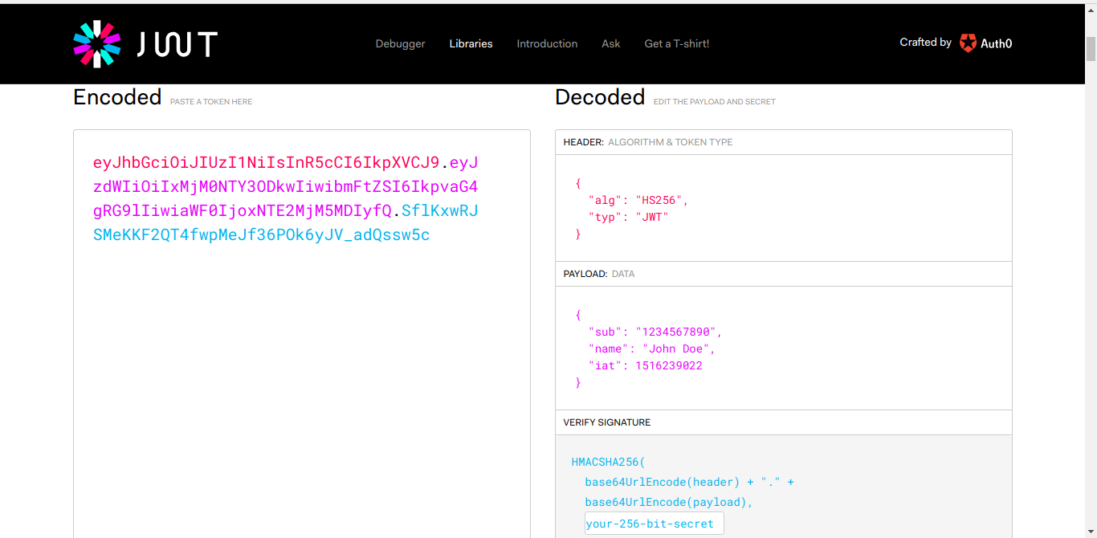

- You can learn React Router here → https://css-tricks.com/learning-react-router/ & https://medium.freecodecamp.org/learning-react-roadmap-from-scratch-to-advanced-bff7735531b6.
- Concept about Redux you can read here → https://medium.com/coderupa/redux-itu-hanya-library-kecil-tapi-c5b23fbd3043.
- Learn about RESTful API → https://searchmicroservices.techtarget.com/definition/RESTful-API.
- RESTFUL API → Intinya oper-operan data dalam bentuk JSON dari frontend ke banckend, dan dari backend ke frontend.
- Learn more about RESTful API → https://www.codepolitan.com/mengenal-restful-web-services.
- You can check API with Postman → https://www.getpostman.com/apps.
- Check status data (created, deleted, etc) you can check it here → https://httpstatuses.com/201.
- For securely transfer data between frontend and backend, we need JSON Web Token, and we can use with JWT, link below → https://jwt.io/.
- Actually, we can use token from JWT (www.jwt.io) and Oauth (https://oauth.net/), but in this case (in Glints Academy) we use JWT.

